**Aggregate functions .**

SQL aggregate functions perform a calculation on a set of values and return single value. They are often used with the GROUP BY clause to group rows that share a property, allowing for more complex data analysis.

Common SQL aggregate functions include:

SUM(): Adds up all the values in a specified column.

AVG(): Calculates the average of the values in a specified column.

COUNT(): Counts the number of rows that match a specified condition.

MAX(): Finds the maximum value in a specified column.

MIN(): Finds the minimum value in a specified column

**TASK**

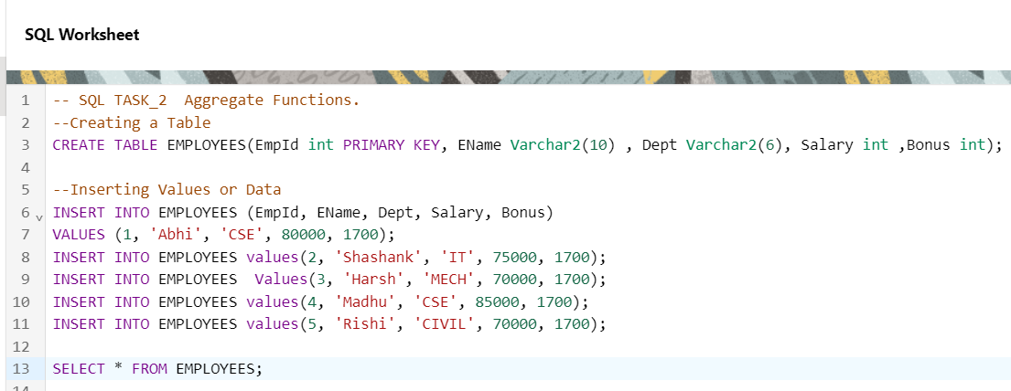

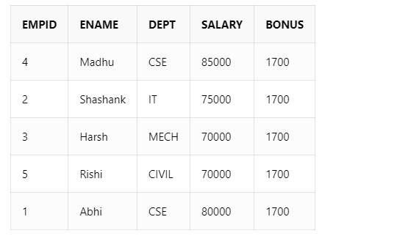

**Aggregate Functions**

1. **COUNT( )**

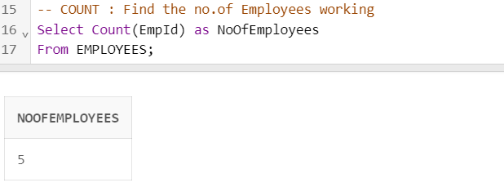

1. **MAX( )**

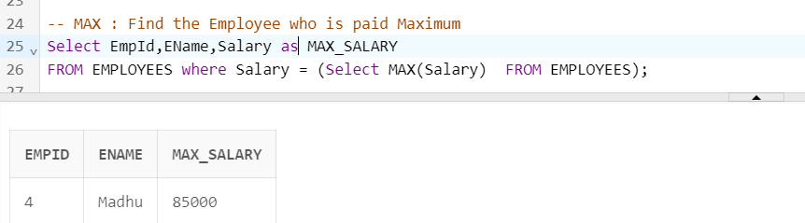

1. **MIN ( )**

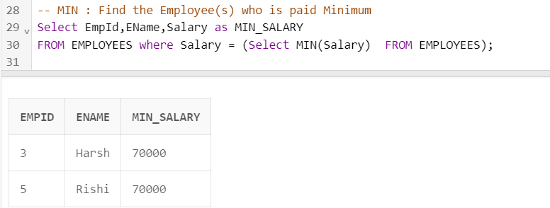

1. **SUM ( )**

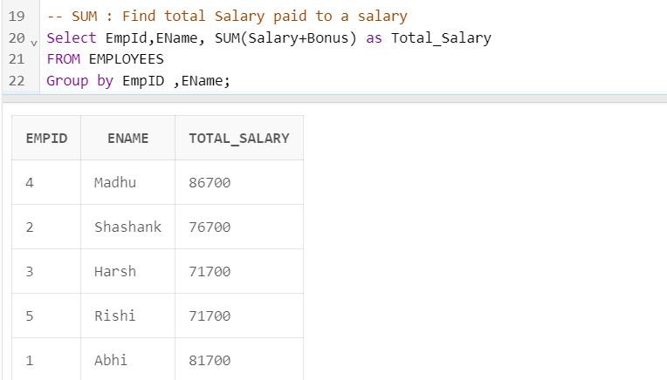

1. **AVG ( )**

